

**Year 12 PHYSICS ATAR 2017**

**Semester 1**

**Task 7: Test 2**

**TASK TYPE: Test**

**CONTENT: Gravity, circular motion and torque – 6%**



|  |  |  |
| --- | --- | --- |
|  | **Possible Marks** | **Your Mark** |
| **Total** | **50** |  |
| **Percentage** | **100%** |  |

**Student Name: ____________________________________**

**Date: ____________________________________**

**Teacher: J. Wijaya**

**Instruction:**

1. **Answer all questions.**
2. **All numeric answers are to be corrected to three significant figures unless specified. Estimated answers are to be corrected to two significant figures.**
3. Kepler’s 3rd law of planetary motion is:

$$T^{2}= \frac{{4π}^{2}}{GM} r^{3}$$

Derive this formula using at least two other equations from the supplied data sheet. Show ALL steps in your working.

[3]

1. Explain why very tall trees growing in a windy environment require a stronger and more extensive root system than similar, but shorter, trees to resist being blown over.

[4]



1. A velodrome is an oval-shaped cycle track, parts of which are steeply banked. The riders on this track are travelling at 15.0 m s-1, the radius of curvature of the banked track is 35.0 m and there is no tendency for the bikes to slide up or down the slope.

track

cyclist

θ

* 1. On the diagram, label all forces including the net force. Then explain the benefits of banked curve using physics concepts you have learnt.

[4]

* 1. Calculate the angle of the bank, θ.

[3]

1. The photograph on the right shows a rollercoaster negotiating a vertical circular loop.

**21.0 ms-1**

**radius = 10.0m**

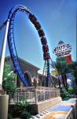

The dimensions of the loop and the rollercoaster’s speed at the bottom of the loop are shown in the diagram below:

* 1. Describe the apparent weight of an occupant of mass 60.0kg when the rollercoaster is at the bottom of the circular loop. Support your answer with a calculation.

[3]

* 1. Calculate the minimum speed **at the bottom** of the circular loop so that the rollercoaster is **just** in contact to the top of the loop.

[5]

1. 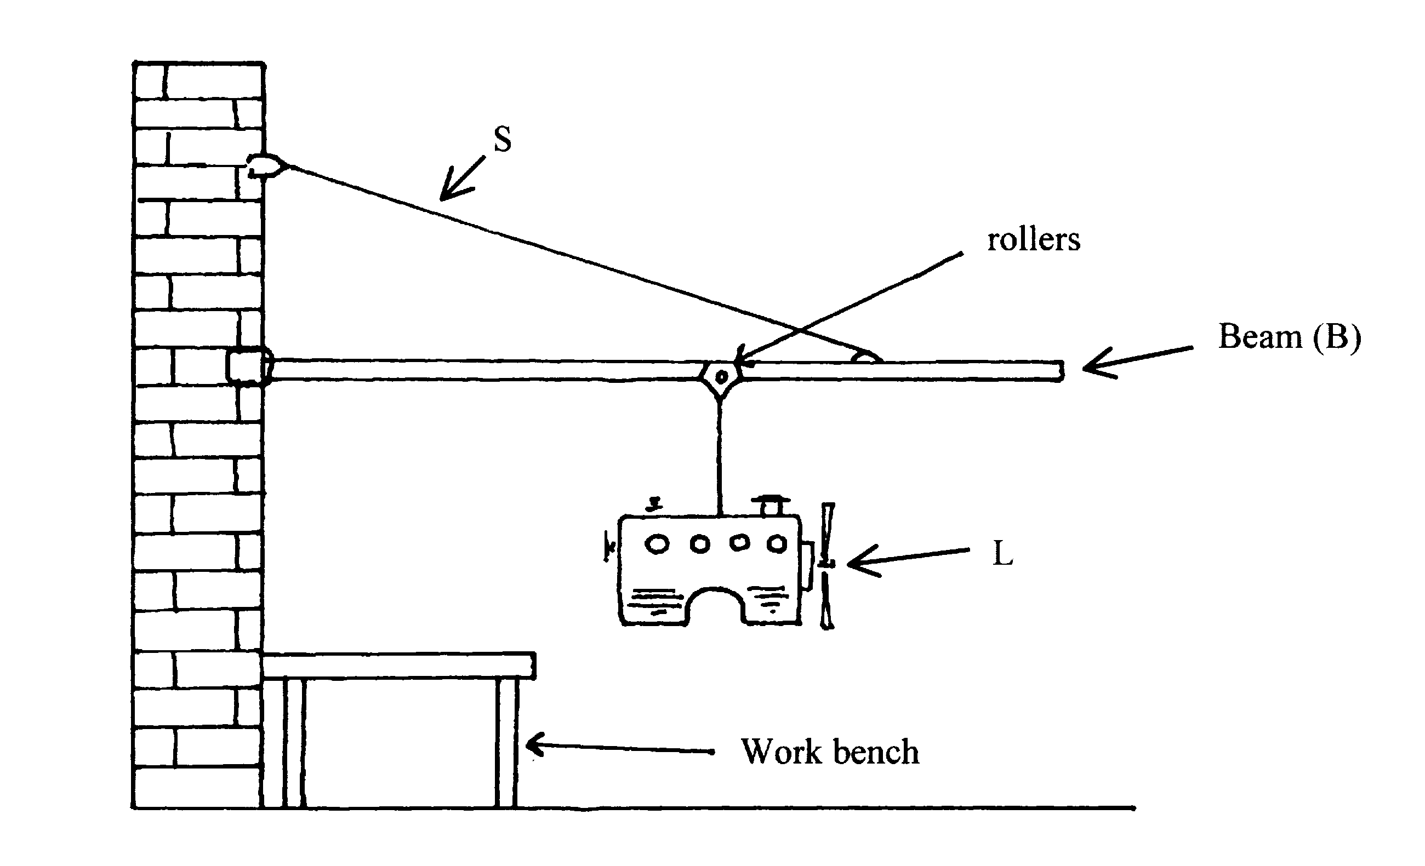The wall crane is designed to lift motors from cars and transfer them to a workbench. It uses rollers to allow the operator to shift the load from one end of the beam to the other as shown in the diagram. The beam (B) is 3.0 m long and the support wire (S) is attached 0.5 m from the outer end at 25.0° to the beam. That is, the angle between S and B is 25.0°.
   1. Calculate the tension S. When the load is 0.25 m from the right end.

[5]

* 1. What would happen to the tension S if the load was gradually being moved toward the end of beam (away from the wall)? Explain your answer.

[3]

**Continue Question 5**

* 1. Calculate the reaction force applied on the beam from the wall.

[5]

1. Neptune has several moons, two of which are Triton and Nereid. Use the following data to answer Parts (a) to (d) where necessary.

|  |  |
| --- | --- |
| **QUANTITY** | **DATA** |
| Mass of Triton | 2.14 x 1023 kg |
| Radius of Triton | 1.35 x 106 m |
| Mass of Neptune | 1.02 x 1026 kg |
| Period of Triton's orbit | 5.08 x 105 s |
| Radius of Nereid's orbit around Neptune | 5.51 x 109 m |

[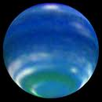](http://www.google.com.au/imgres?imgurl=http://starryskies.com/articles/2003/05/neptune.jpg&imgrefurl=http://starryskies.com/articles/2003/05/neptune.html&usg=__RgZiXmmOdPBR7oaD4Vdi8gltsaI=&h=500&w=500&sz=17&hl=en&start=13&itbs=1&tbnid=EFHdybTgbIIU-M:&tbnh=130&tbnw=130&prev=/images?q=neptune&hl=en&gbv=2&tbs=isch:1)

* 1. A spacecraft is at rest on Triton's surface. One of the experiments on board involves a 10.0 kg mass hanging at rest from a spring balance. The scale of the spring balance is correctly calibrated in Newtons. What is the reading on the spring balance? Show your working.

[2]

**Continue Question 6**

In parts b), c) and d), the spacecraft (mass **2.00 x 103 kg**) is in a circular orbit with its engines off at **an altitude of 2.70 x 106 m** above Triton, as shown in the diagram.

**Spacecraft**

**2.70 x 106 m**

## In physics terms, describe what is meant by being in 'orbit'? [2]

* 1. Calculate the gravitational field strength at this altitude due to Triton.

[3]

* 1. The 10.0 kg mass is still attached to the spring balance as before. What is the reading on the spring balance now? Give reasons for your answer.

[3]

**Continue Question 6**

The orbital period of Nereid around Neptune is approximately the same as that of the Earth around the Sun (that is 365.25 earth days).

* 1. Calculate the average orbital speed of Nereid around Neptune.

[2]

* 1. The length of one day on Neptune is 16 hours, 6 minutes and 36 seconds. Calculate the altitude of a geosynchronous orbit around Neptune. Show all working.

[3]



**End of the test**